**Documentation and Screenshots for Backend and API Testing for Shoppe Globe application**

**GITHUB Link :** https://github.com/VishalTorne221992/Shoppe_Globe_App.git

1. **Register a user in the application using passportjs**

* **VSCODE Screenshot :** Adding the request body with user details.

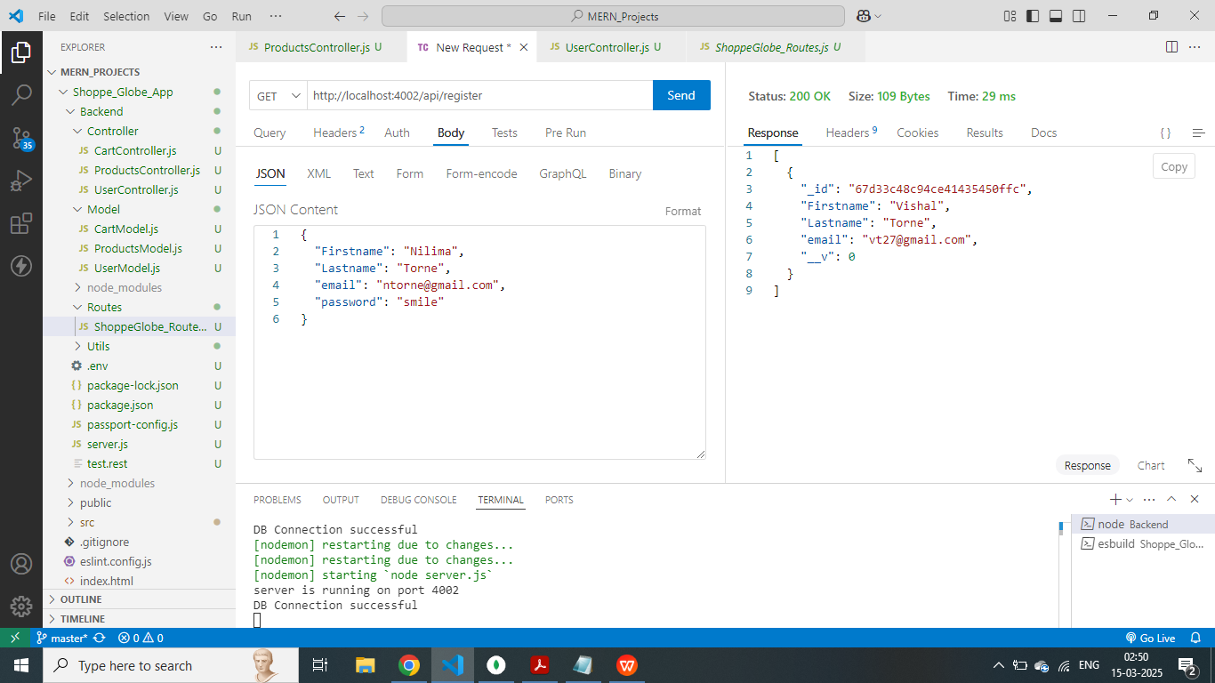

* **VSCODE Screeshot:** Successfully registered the user in mongodb using passportjs.

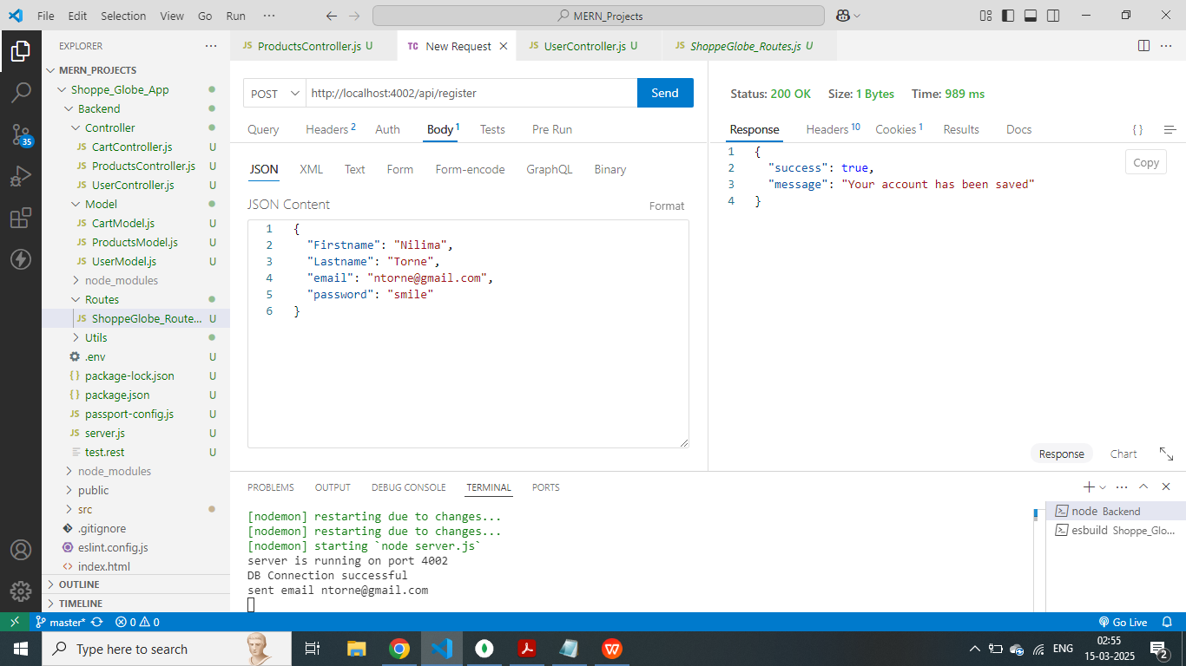

* **MongoDB Screenshot :** Successfully added a new user to Mongodb.

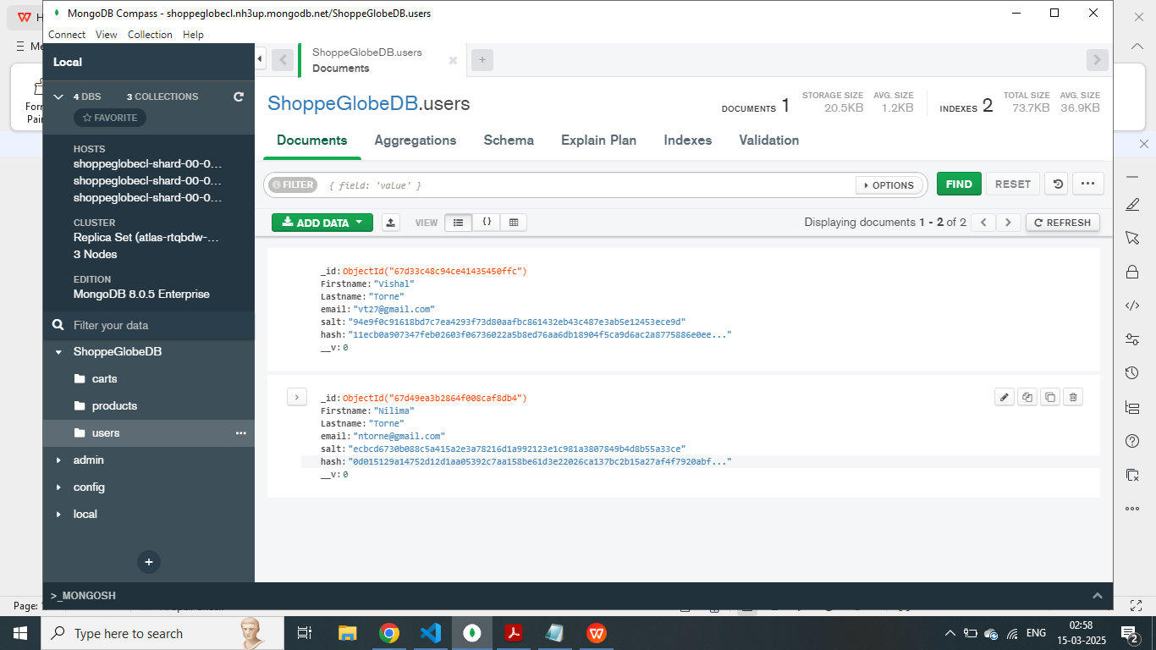

1. **Login using the registered credentials.**

* **VSCODE Screenshot :** Logged in succesfully with the email and password of registered user and received a jwt signed token which will be used to authorize the protected routes.

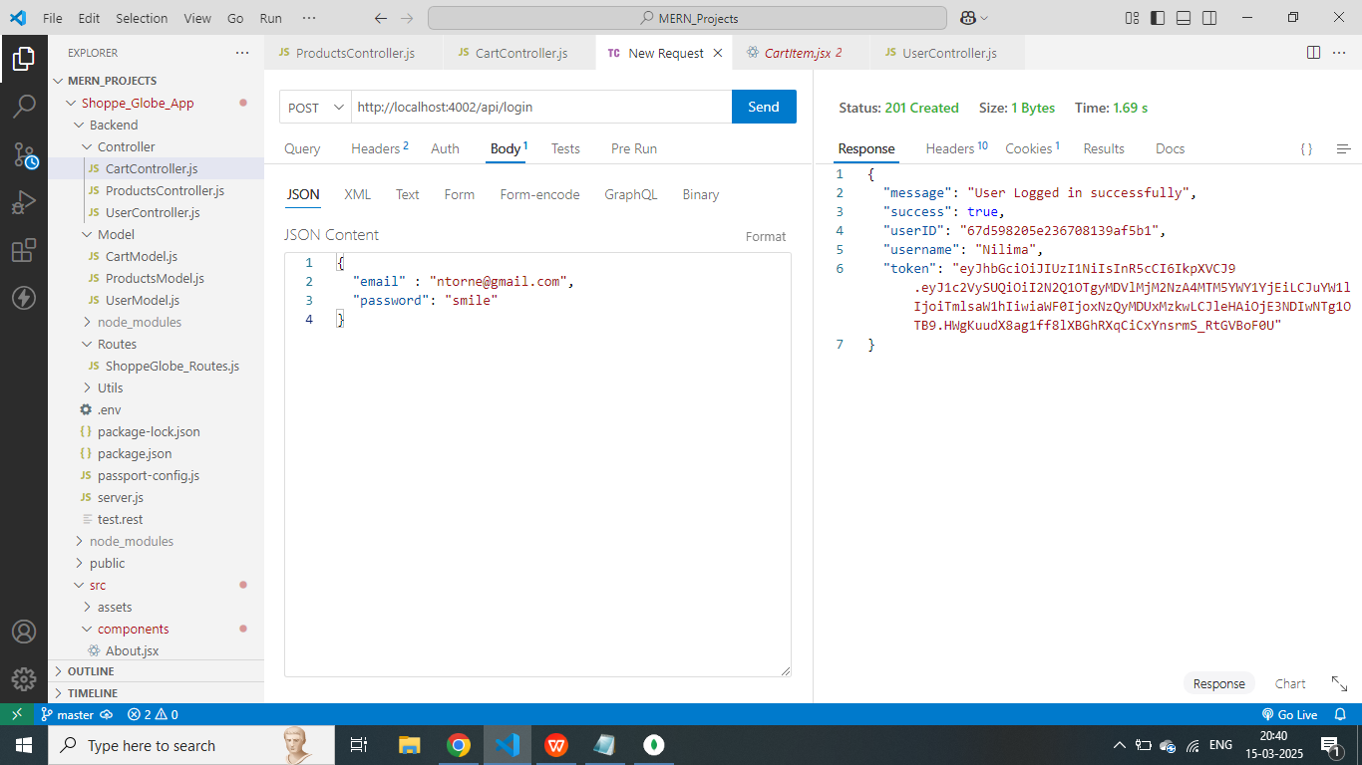

1. **Get all products route**

* **VSCODE Screenshot :** Received all the products with the route **<http://localhost:4002/api/products>**

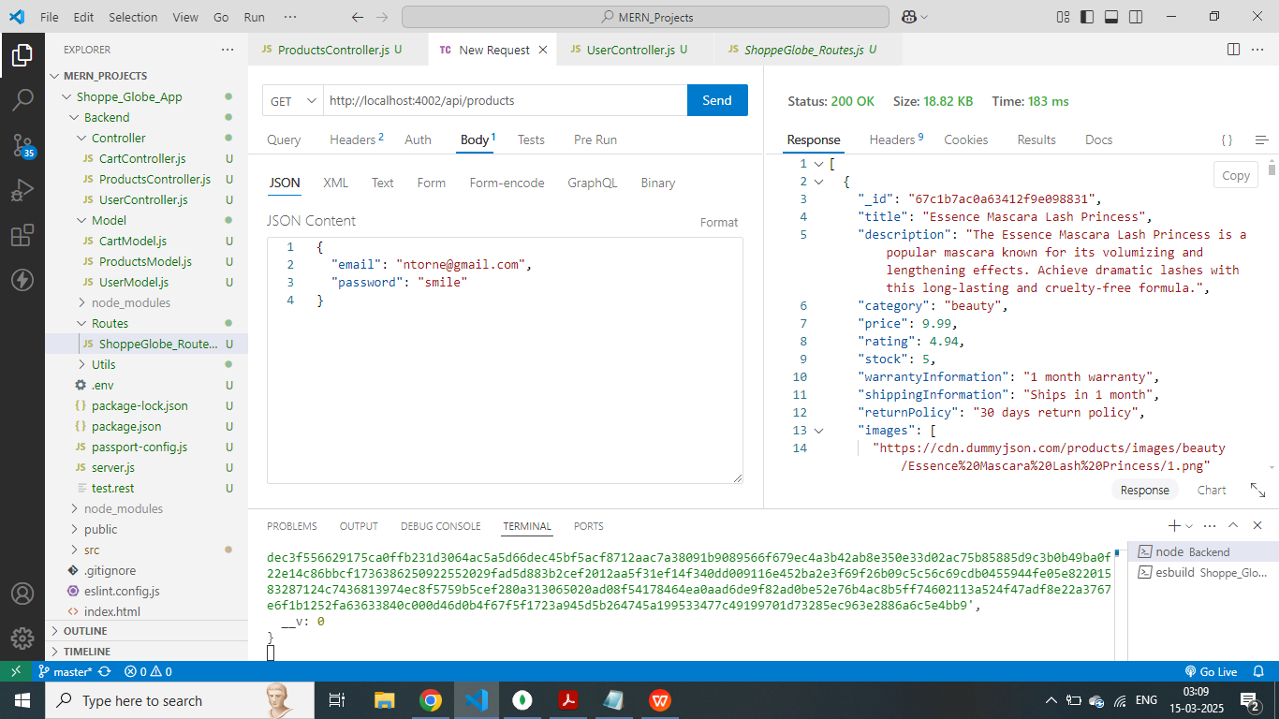

1. **Get product by ID**

* **VSCODE Screenshot :** Get a products detail using the products ID

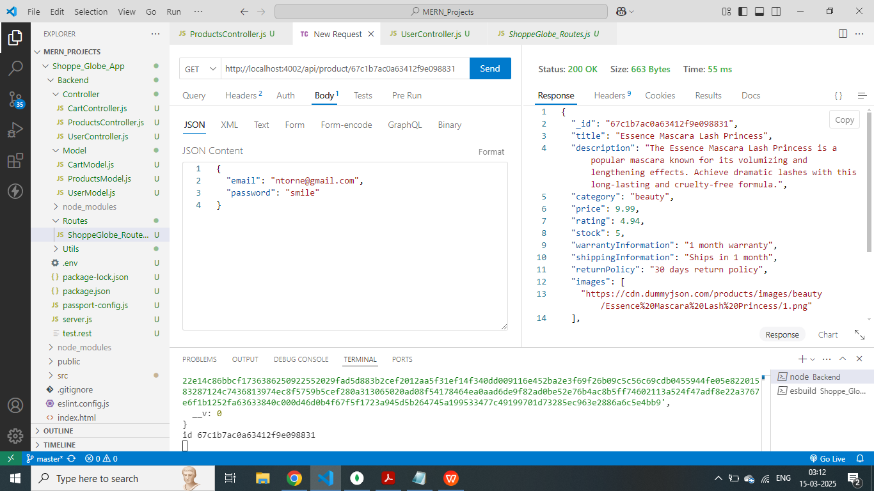

1. **Checking if the user is logged in and has authorized token to create a cart**

* **VSCODE Screenshot :** Successfully checked if the user is authorized and has the correct jwt token, we can check it in the authorization header which is sent in the request header with the “/api/cartAuth” route. User is authorized to use the cart page.

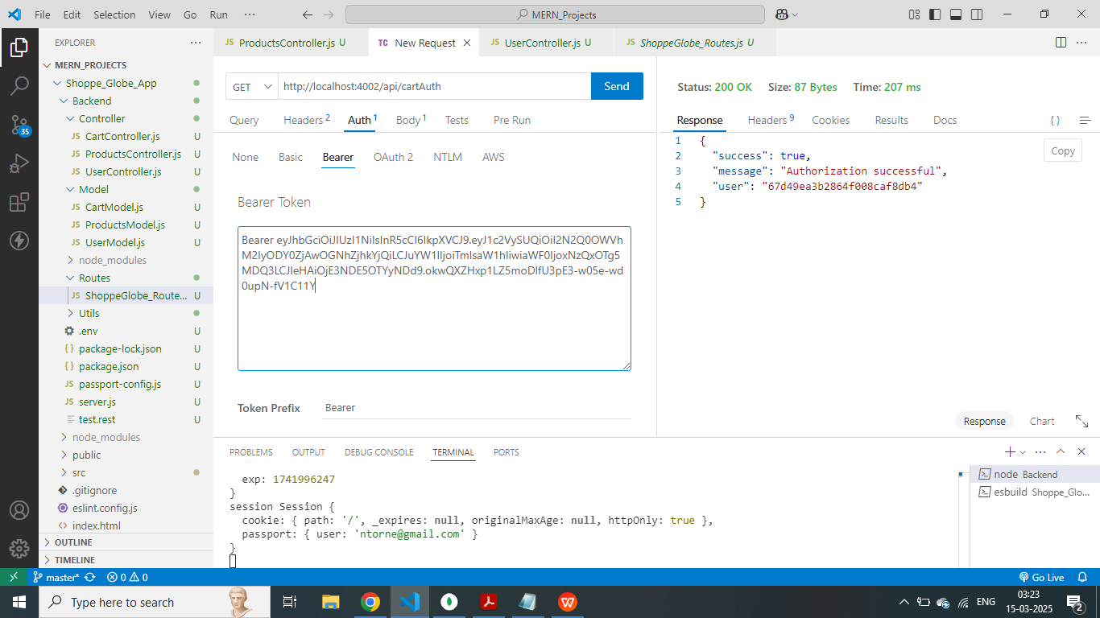

1. **If user token is incorrect then user is forbidden from the accessing the cartpage.**

* **VSCODE Screenshot :** Successfully shown forbidden message if incorrect token.

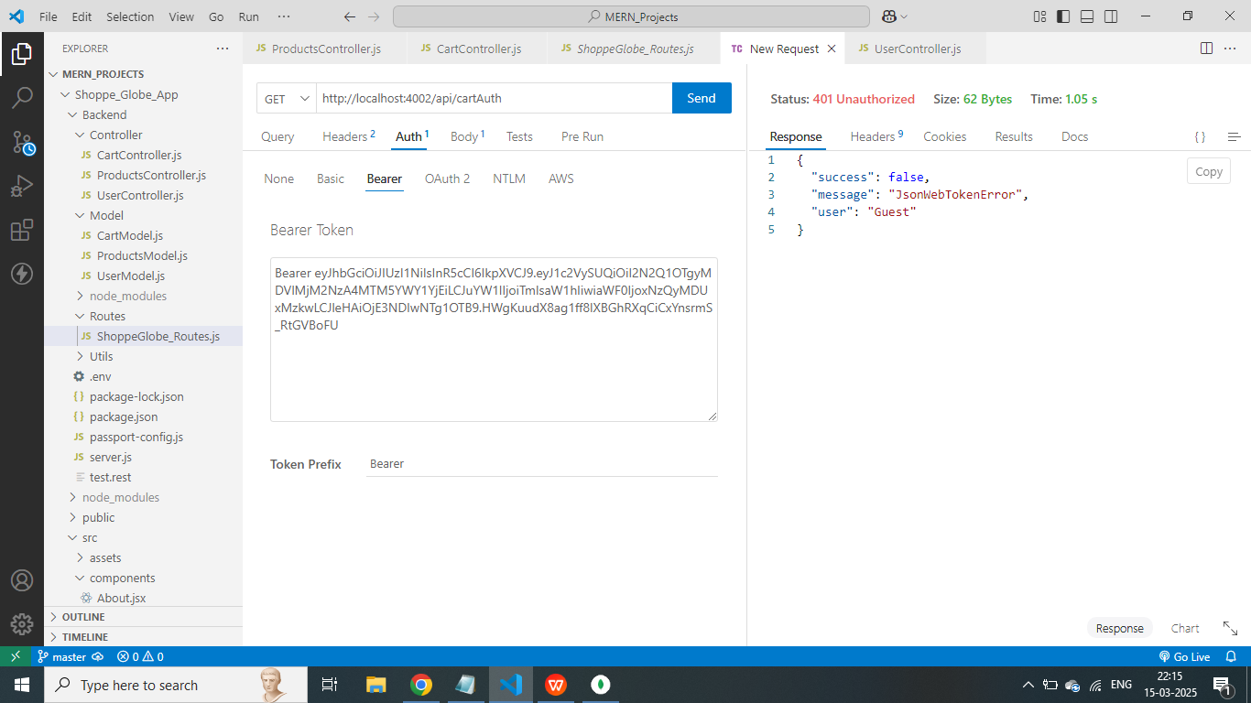

1. **If the user jwt token is expired and session is expired**

* **VSCODE Screenshot :** If the user jwt token is expired the access is revoked and show error of token expired.

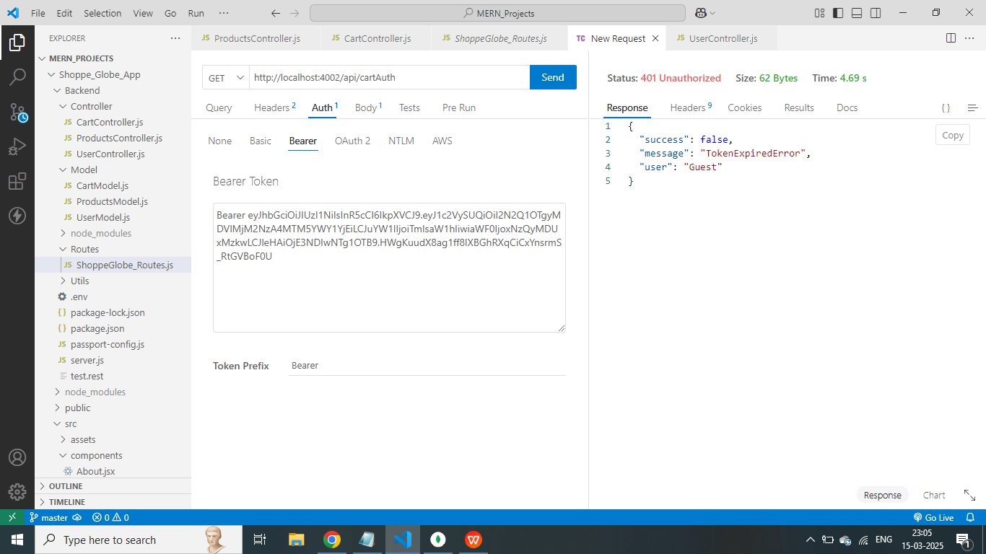

1. **Create cart for the user and add products to the cart.**

* **VSCODE Screenshot :** Successfully created a cart for authorized user.

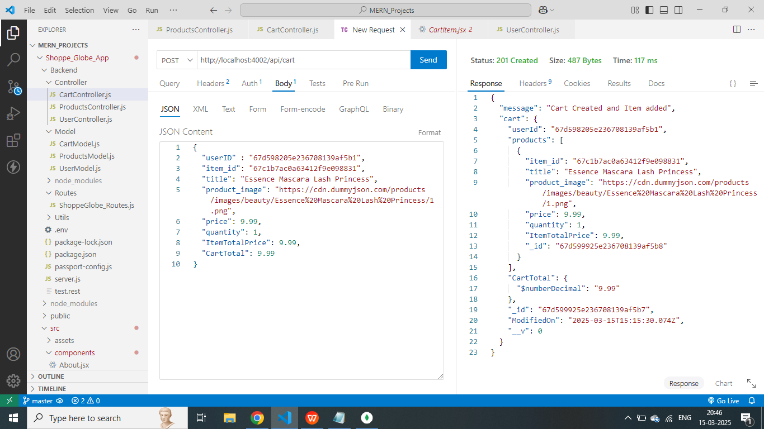

* **MongoDB Screenshot : Successfully created a cart and added product**

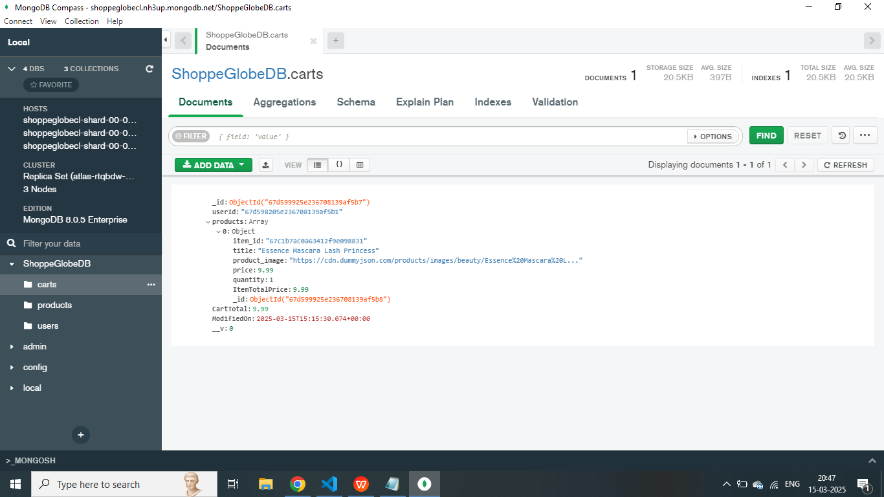

1. **Get all products added to the cart**

* **VSCODE Screenshot :** Successfully received all the products added to the cart from mongodb database.

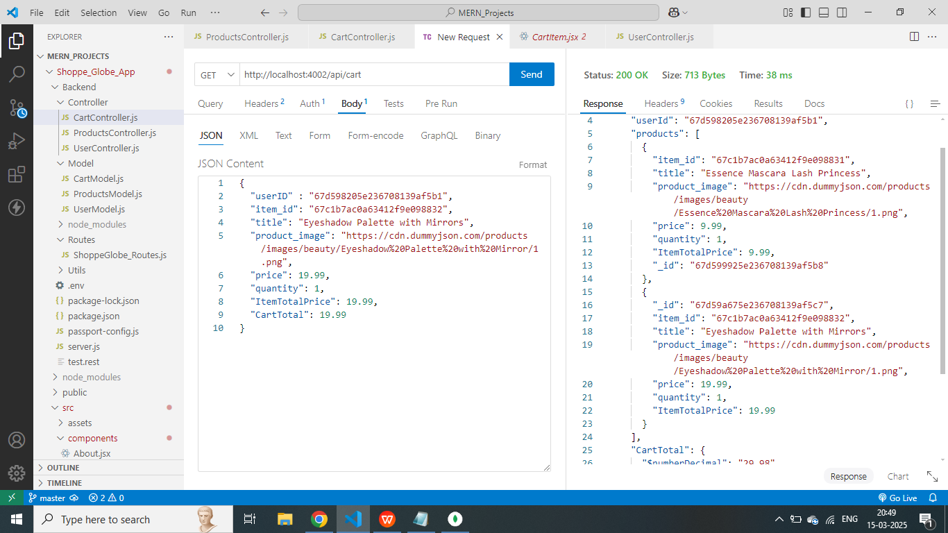

* **MongoDB Screenshot :**

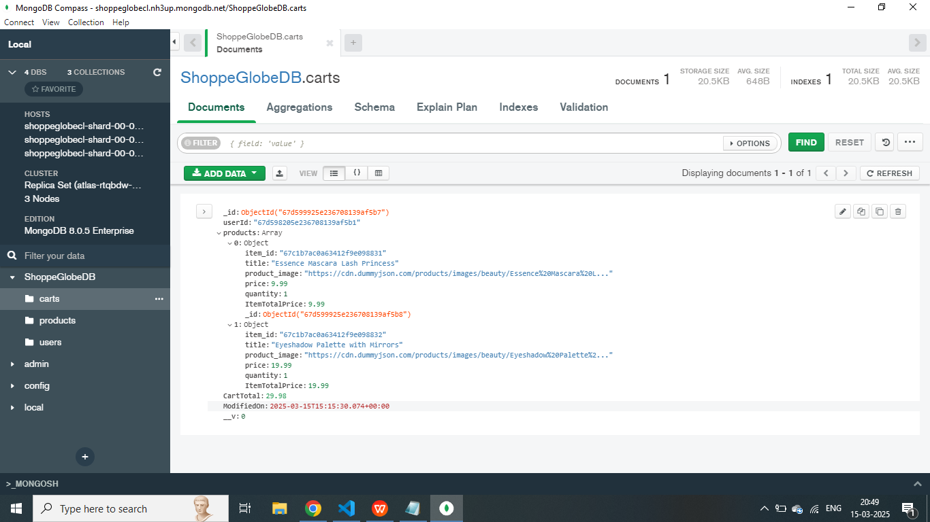

1. **Update the product quantity of the cart and increment product quantity by 1.**

* **VSCODE Screenshot :** Successfully incremented the quantity by 1 and received the message “Incremented Quantity” and same updated in the MongoDB Database.

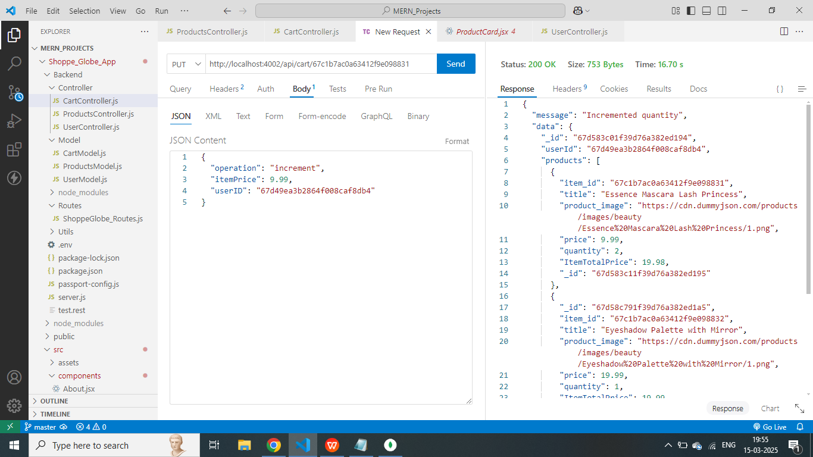

* **MongoDB Screenshot :** Successfully updated quantity in the MongoDB

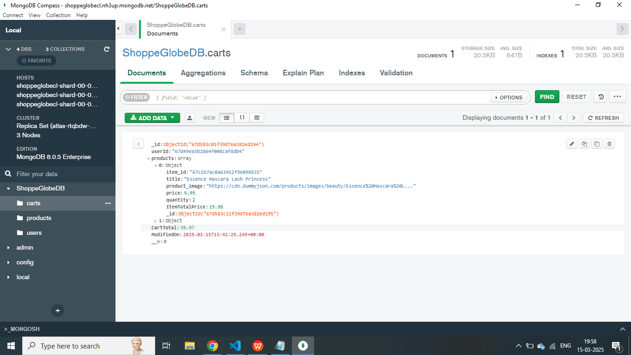

1. **Update the product quantity of the cart and increment product quantity by 1.**

* **VSCODE Screenshot :** Successfully decremented the quantity by 1 and received the message “decremented Quantity” and same updated in the MongoDB Database.

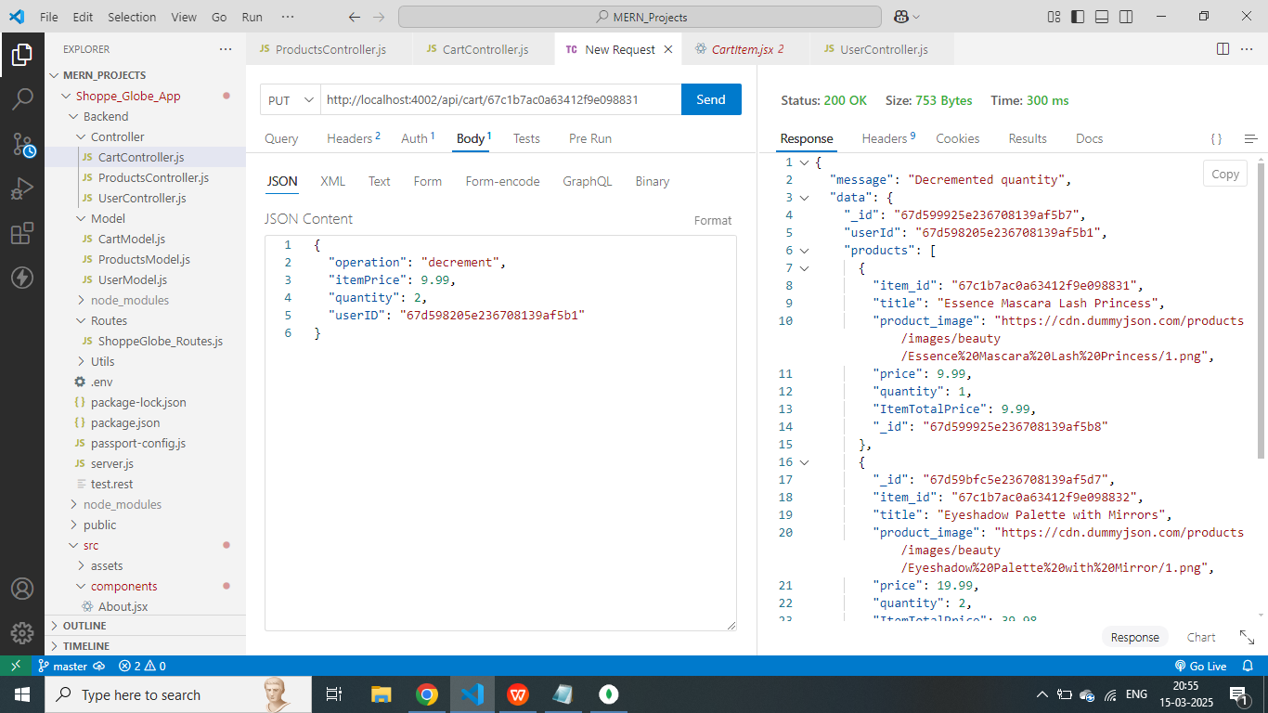

* **MongoDB Screenshot :** Successfully updated quantity in the MongoDB and decremented quantity.

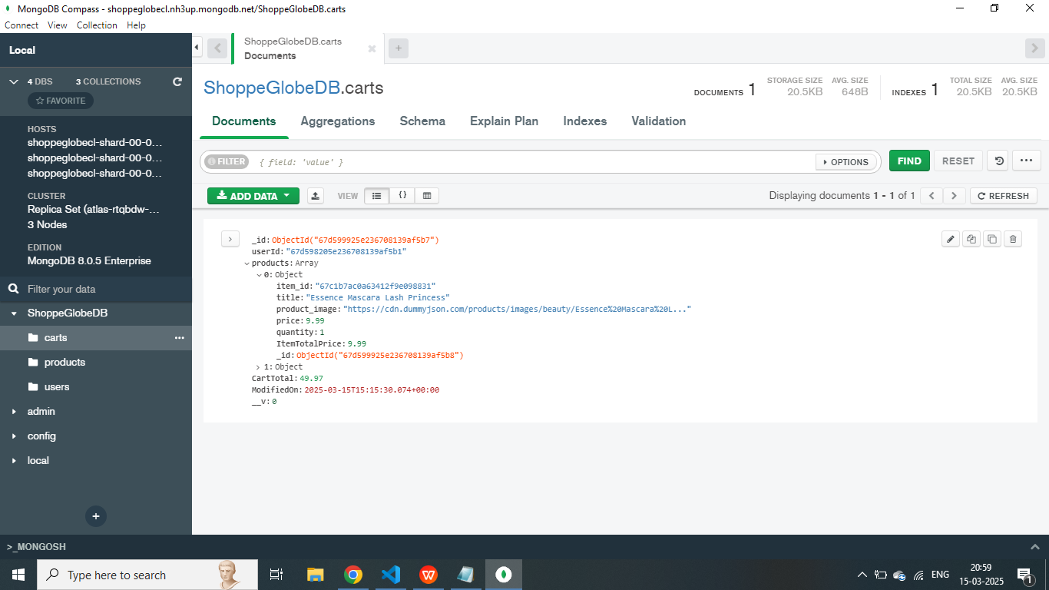

1. **Delete the product if the product quantity decremented less than 1**

* **VSCODE Screenshot :** Successfully deleted the product if product decremented less than 1 quantity and cartotal deducted.

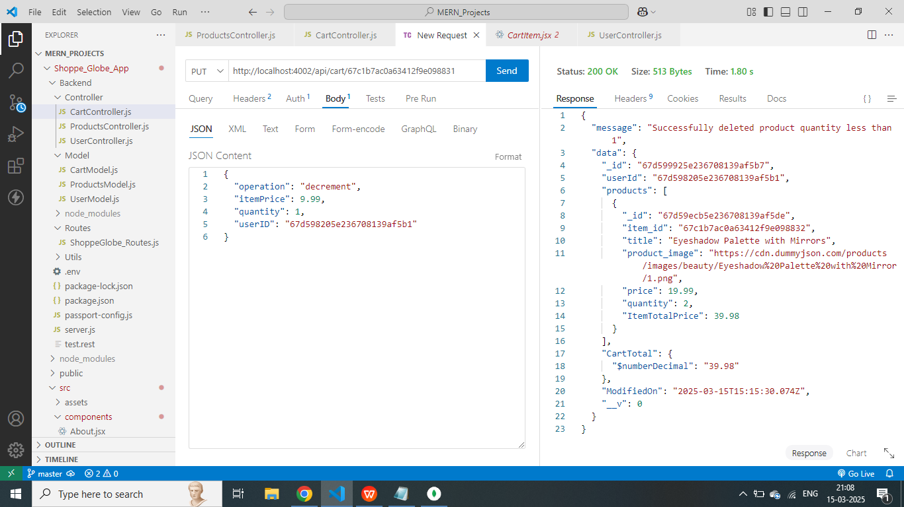

* **MongoDB Screenshot :** Successfully updated products in Mongodb.

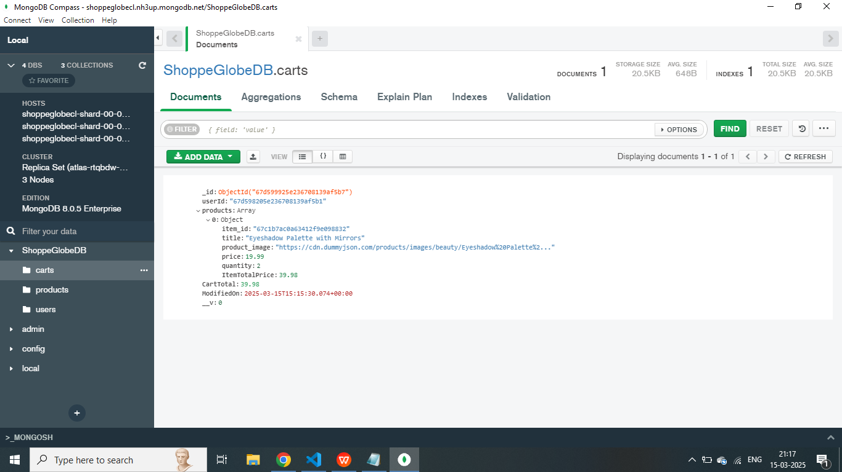

1. **Delete product from the cart based on ProductID.**

* **VSCODE Screenshot :** Successfully deleted product from the cart and decremented total item price from the cart total.

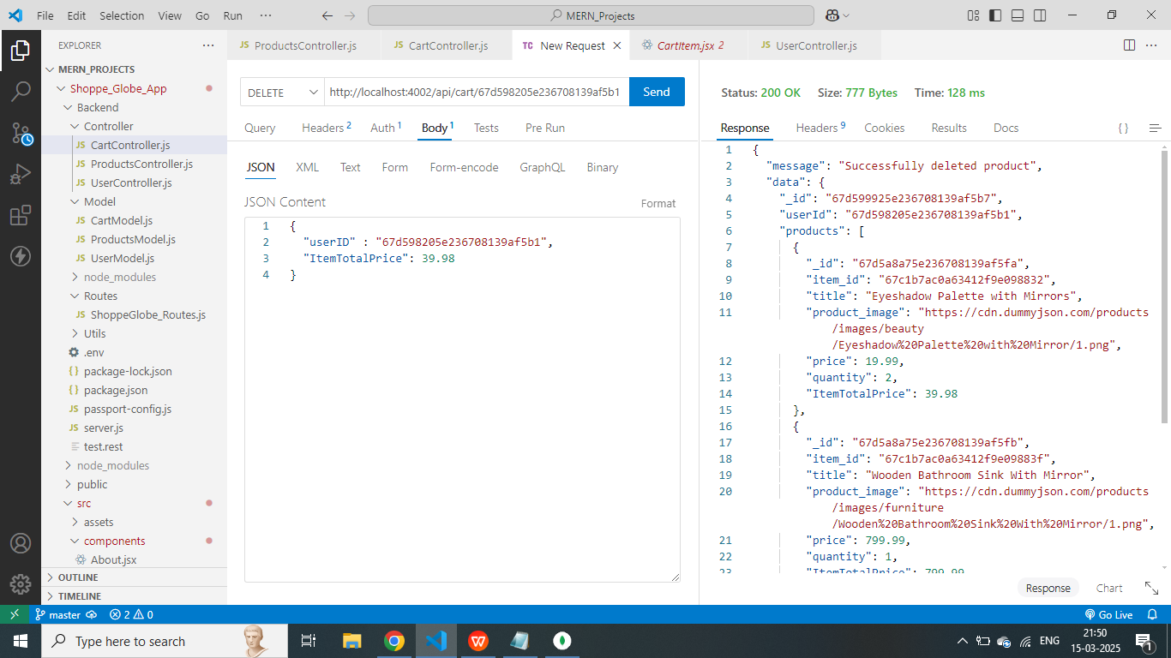

* **MongoDB Screenshot :** Successfully deleted the product and updated the Cart total in MongoDB.

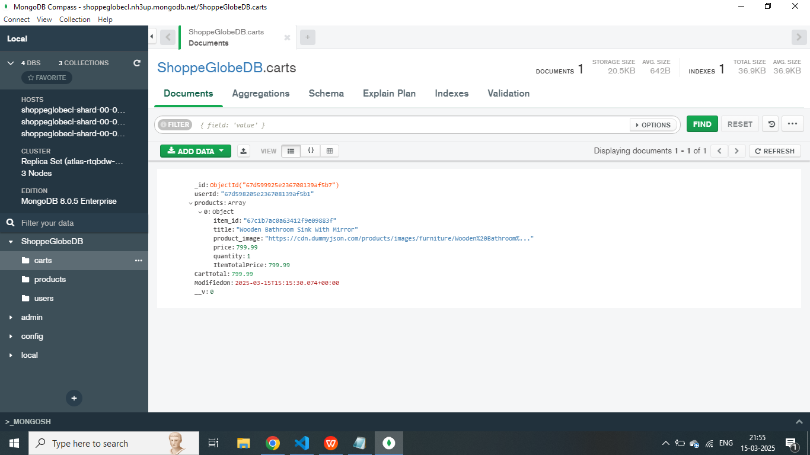

1. **LogOut the user.**

* **VSCODE Screenshot :** Successfully logged out user from the application and the cart saved for future access.

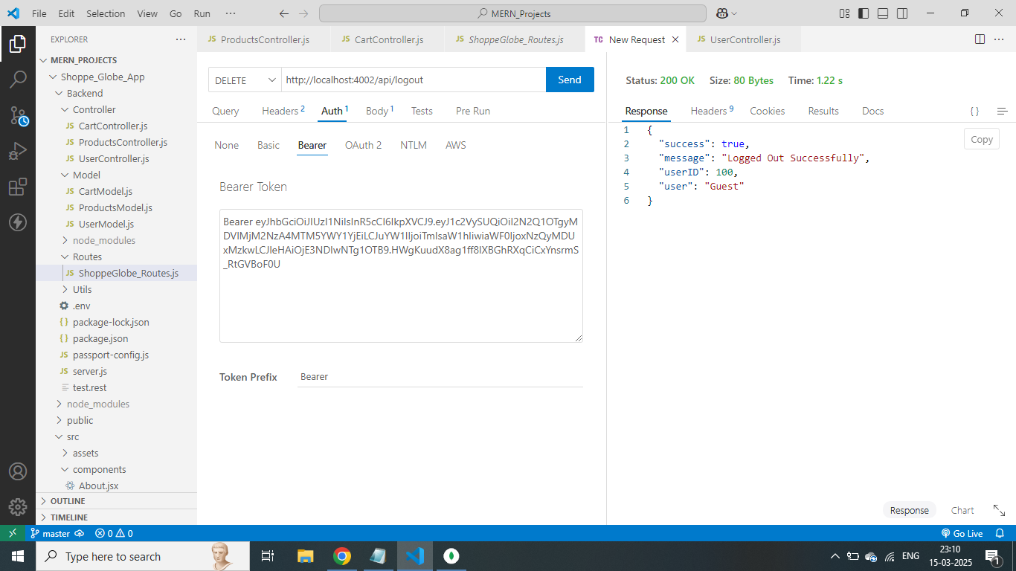

**THE APPLICATION DOCUMENTATION**

1. **Homepage**

The Homepage consists of the Header section and the main section for the viewing of the categories, products.

* **Header Section**

1. Header section consists of the logo of the application and the Username and Login components such as the Log in and logout buttons and Sign up button to register the new user.
2. When the user clicks Login button the login popup appears and user has to login to add products to the cart and view checkout pages.
3. When the user clicks on the sign up button the a Register a new user popup box opens and user needs to fill the form and register in the application and then log in using the login button to log into the application

* **Main Section**

1. User can view the categories and view the products of the specific categories and add products to the cart and view the cart page to see the items which are added to the cart.

**Home page Login modal**

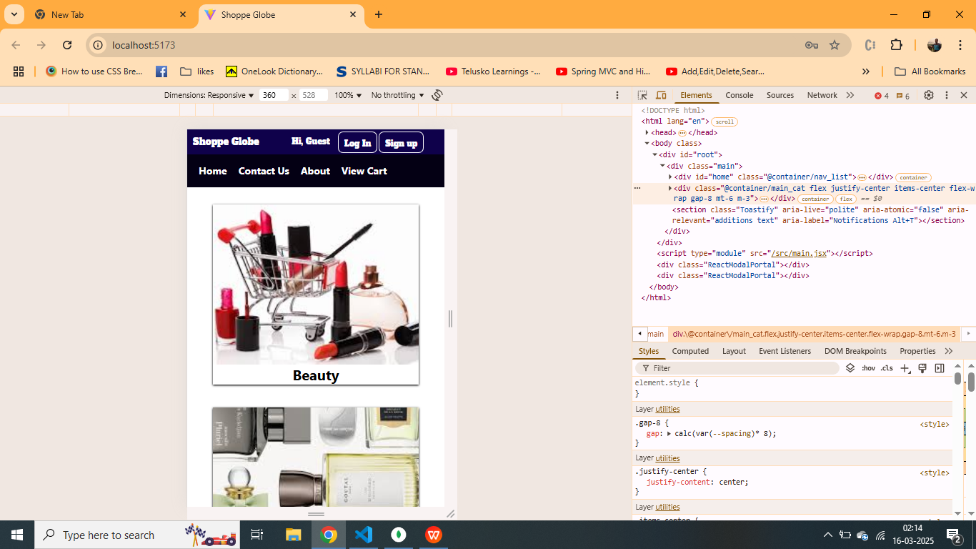 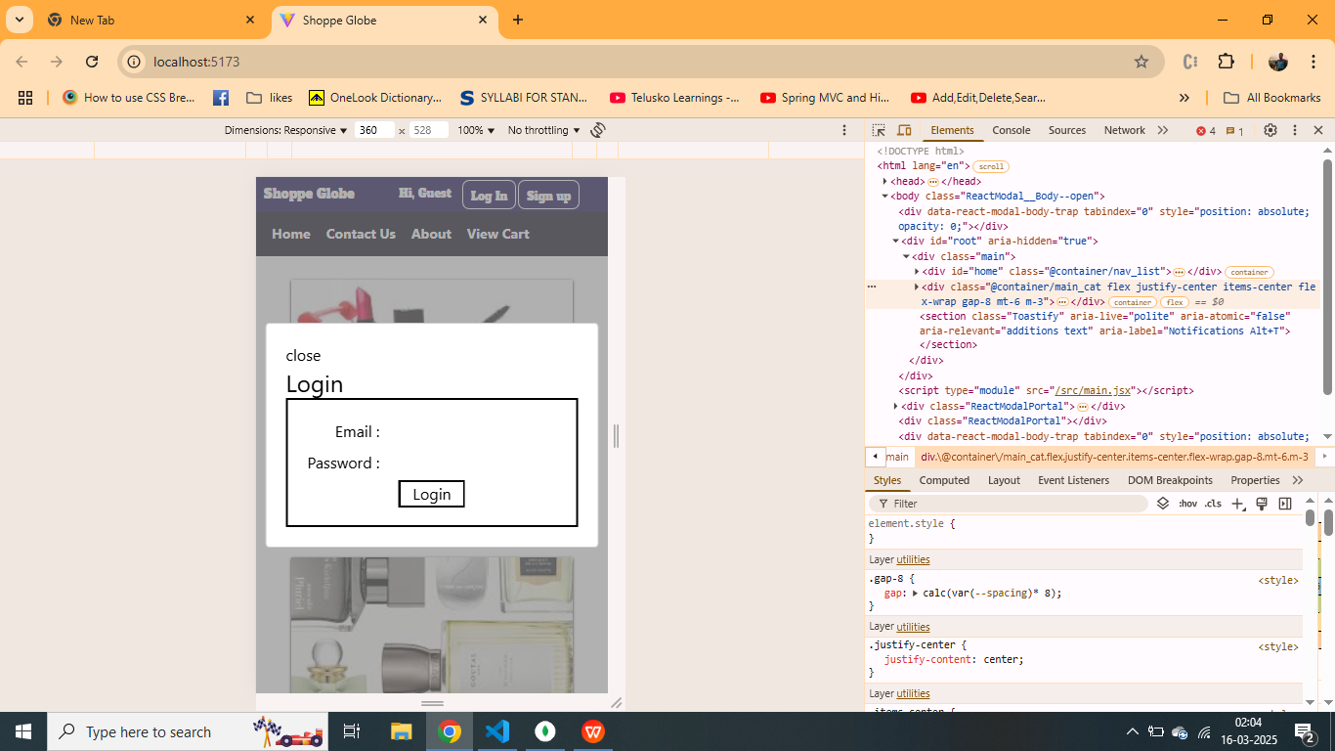

**Registeration form modal**

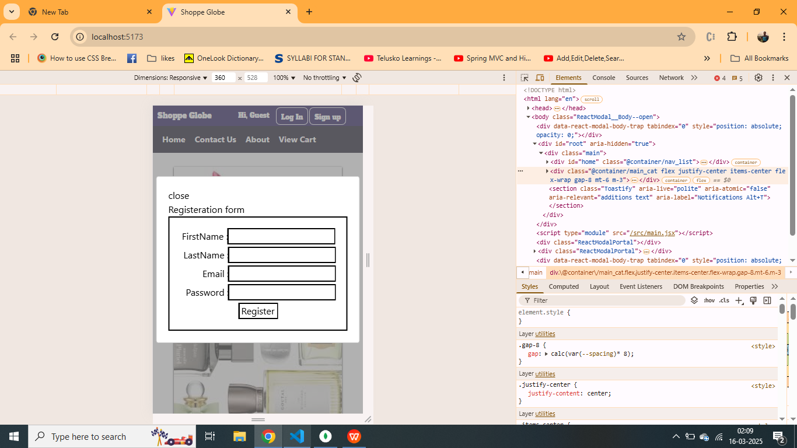

1. On successful login of the user the user can now add the products to the cart.

**User Logged In Username appears with log out**

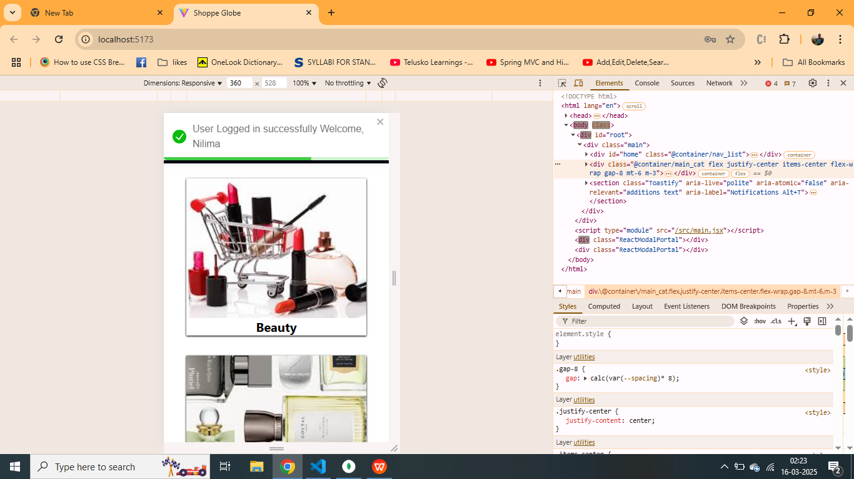 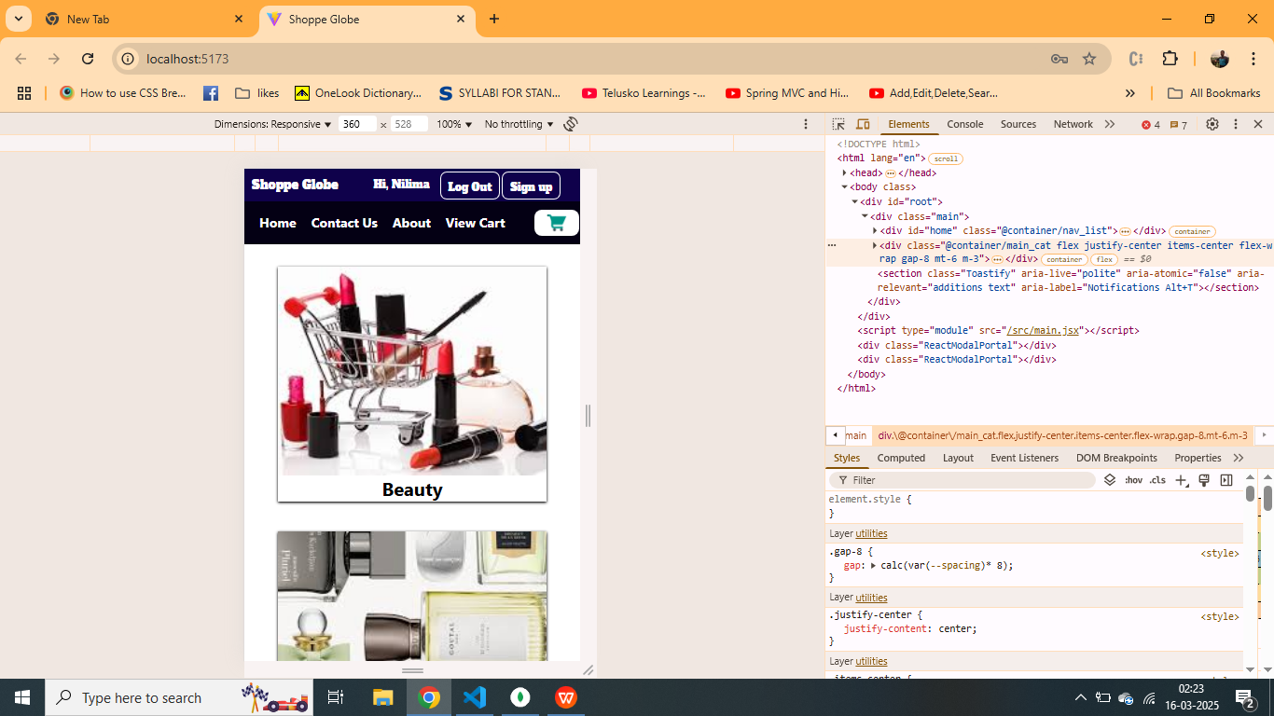

**2.** **Category Products page**

User can view the products of the specifice category and view the details such as price and description and ratings.

**Category Products page**

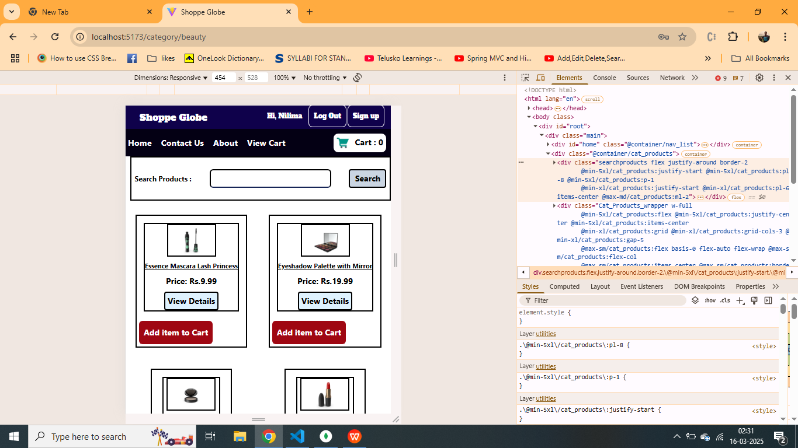

**User can add items to the cart and Cart button shows number of items**

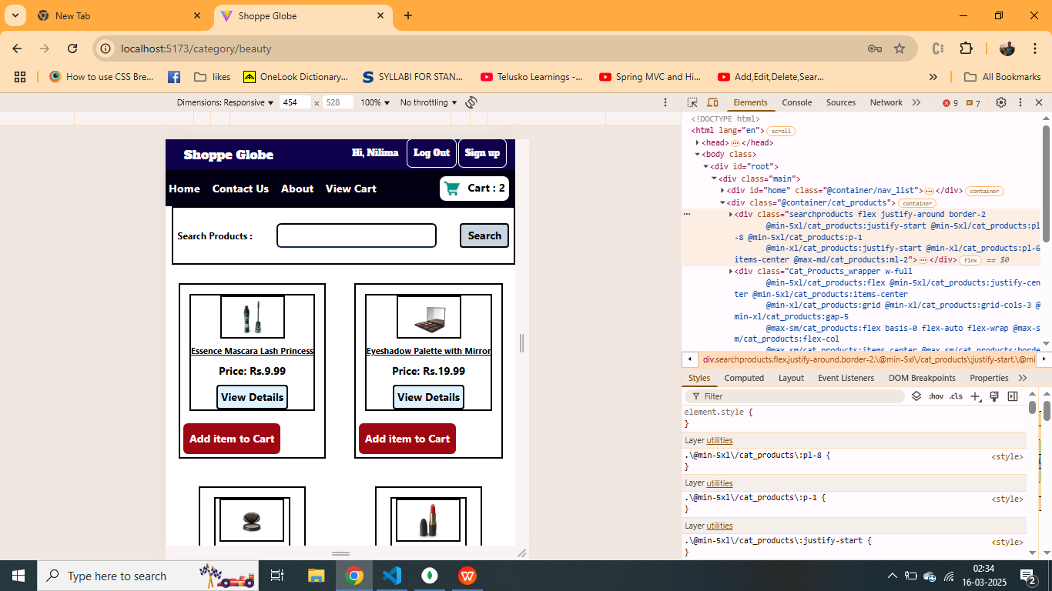

**3. Cart Page**

1. If the user is authorized or logged in only then he can view the cart.
2. View cart to see the items they have added and see the total amount and they can proceed to checkout page.

**Cart Page Cart Pop after clicking cart icon**

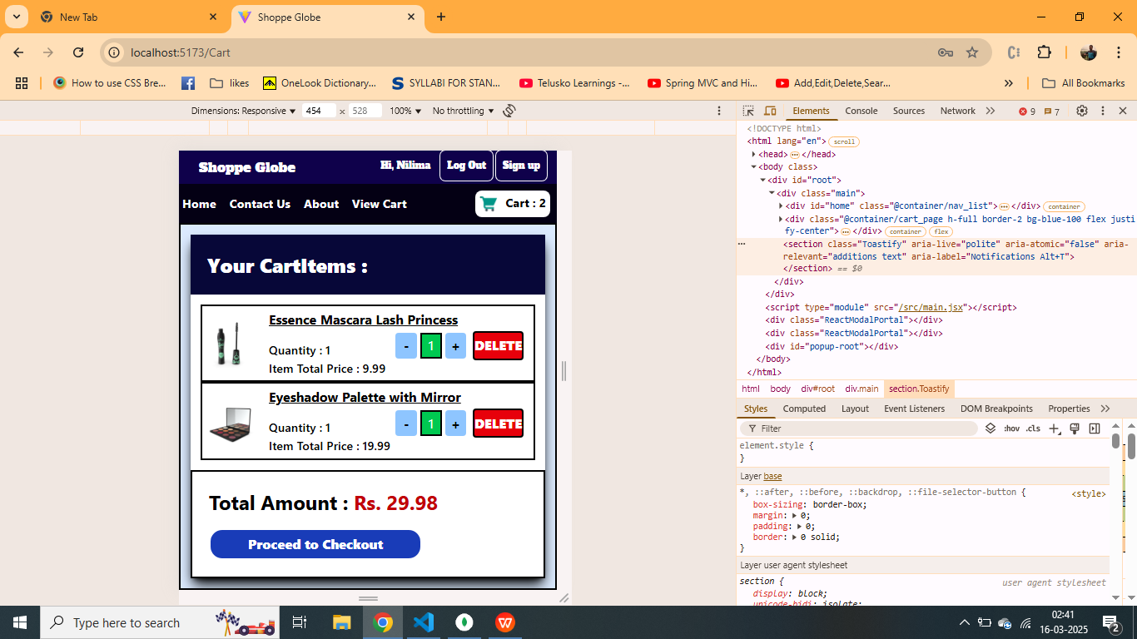 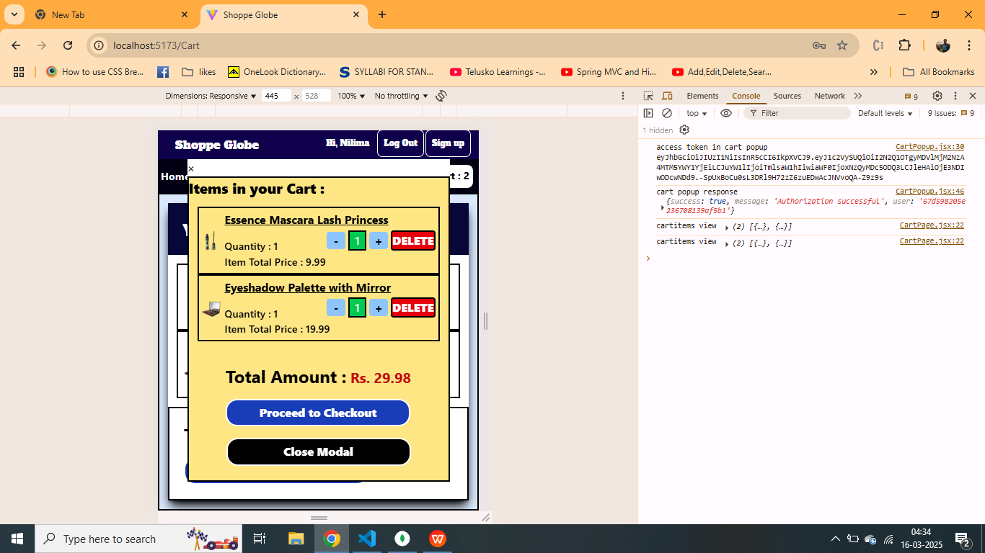

1. If the session expires due to inactivity the user will be logged out automatically at any stage and

Prompted to login again.

**Session expired due to inactivity**

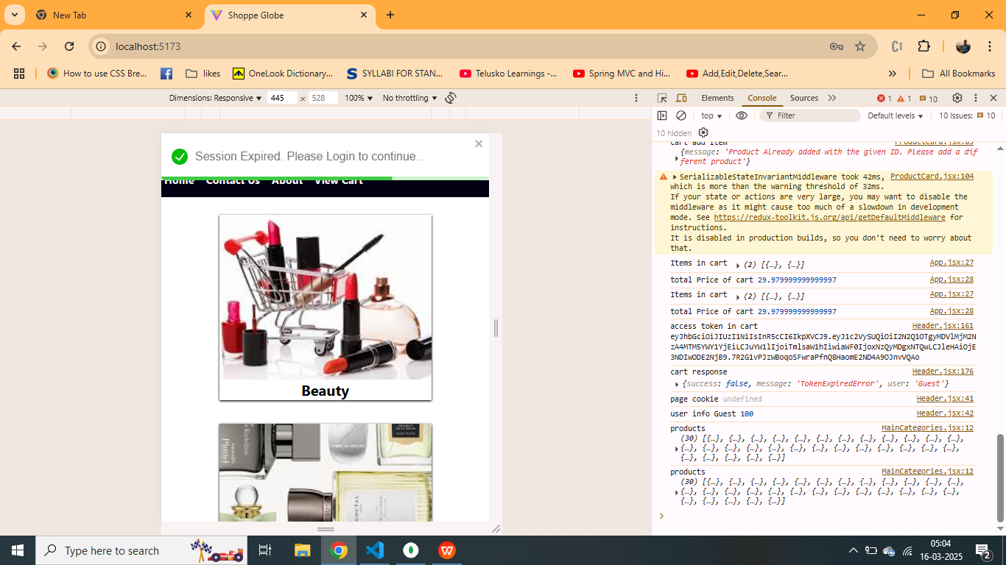

**4. Checkout page**

After the adding the products to the cart, user can move to the checkout page by clicking the checkout button on the cart page or cart pop modal. It will show the total amount and a link to payment page.

**Checkout Page**

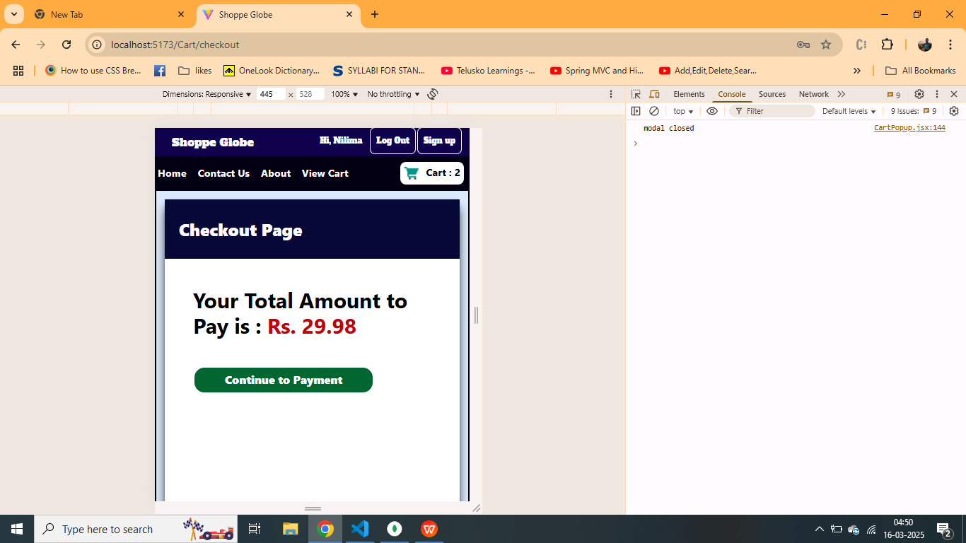

**5. Logging out of the application.**

After viewing the application or ordering items from the website the user can logout by clicking the logout button

**Logged out successfully**

